SSL Certificate Renewal

TIMING
These steps need to occur ANNUALLY. (We suggest it happens just prior to the new school year.)

Overview
The process is fairly straightforward and will require two separate 5–15-minute work sessions
- Generate new .csr and .key files - for both the production and sand servers
- Copy the .csr files to your local machine and email each of them to ITS
- ITS requests new certificates and forwards them to Informatics
… (wait) …
- Download the *.PEM certificates and install them on the respective servers
- Update each servers ssl_certificate files to point to the new .key and .csr files
- Restart the services
- Verify the certificate
(All others listed below)

STEP 1: Generate new *.csr and *.key files
References:
- “What is the Certificate Signing Request (CSR)?” - https://www.encryptionconsulting.com/education-center/csr/
- “How to Install OpenSSL from Source in CentOS and Ubuntu” (all necessary steps are listed below)
https://www.tecmint.com/install-openssl-from-source-in-centos-ubuntu/

For both the SAND and PROD servers: (you can use the “putty” app to accomplish logging into each server)
- vs-dentappsnd
- vs-dentappprod
  - ssh into server
  - ssh (username@vsdentappsnd or username@vsdentappprod)
We will use the year of renewal to help distinguish the files name from previous years certificate process.
Once in your terminal change to the /tmp directory
cd /tmp
For authorization you may need to preface the command with “sudo”.
`sudo openssl req -new -newkey rsa:2048 -nodes -keyout <file.key> -out <file.csr>`
Do this for:
- musod_prod_<year>.<ext>
- musod_sand_<year>.<ext>
- phone_api_prod_<year>.<ext>
- phone_api_sand_<year>.<ext>
Once the command executes follow the example listed below. Note: We do NOT need the information of an email, the challenge password or an optional company name – you may leave these blank.
................................................+++++..............+++++
writing new private key to 'musod_sand_2025.key'
-----
You are about to be asked to enter information that will be incorporated
into your certificate request.
What you are about to enter is what is called a Distinguished Name or a DN.
There are quite a few fields but you can leave some blank
For some fields there will be a default value,
If you enter '.', the field will be left blank.
-----
Country Name (2 letter code) [XX]:US
State or Province Name (full name) []:Wisconsin
Locality Name (eg, city) [Default City]:Milwaukee
Organization Name (eg, company) [Default Company Ltd]:Marquette University
Organizational Unit Name (eg, section) []:Dental
Common Name (eg, your name or your server's hostname) []:*.marquette.edu
Email Address []:.

Please enter the following 'extra' attributes
to be sent with your certificate request
A challenge password []:.
An optional company name []:.
................................................+++++..............+++++
A .csr file and .key file will be created in the /tmp dir.
If you make a mistake, simply remove the files (rm musod_sand_2025*.*) and rerun the command.

STEP 2: Copy CSR files TO Local Machine and Email to ITS
Now send the generated files to ITS
- Copy the .csr file to local machine.
- Send the .csr files from both the sand and prod servers to IT security (Trevon Forbes. CC: Jeremy Edson)
- Include the following information to the ITS email as well:
For the prod server: vs-dentappprod
- musod.marquette.edu
- dental-apps.marquette.edu
For the sand server: vs-dentappsnd
- musod-sand.marquette.edu
- dental-apps-sand.marquette.edu
NOTE: Request a response be sent to the Director, yourself, and the general muinformatics@marquette.edu emails!!!
(We are requesting this so that their response does not “fall through the cracks”!)
It is NOT a multi-domain certificate as it is a “wild card” certificate. ITS will register. Once approved, an email with several links will be sent to the informatics developer.

STEP 3: ITS requests new certificates and forwards them to Informatics
- ITS will request the Certficate files for each server. (At this point we simply wait for a response.)

Step 4: Download the *.PEM certificates and install them on the respective servers
Once approved, an email with several links will be sent to the informatics developer.
- Use the link that say “Download 'as Certificate only, PEM encoded' certificate file.”
There will be Separate certificate files for prod and sand servers.
- Rename this to avoid confusion: For example: “musod_sand_2025_cert.cer”
- SCP the certificate file to /tmp directory on the server
- The /tmp dir should have the key (created earlier) and certificate file now.
For example (Repeat for prod):
  - musod_sand_2025.key
  - musod_sand_2025_cert.cer (original .PEM file)
  - musod_sand_2025.csr (not needed now)
- Copy the files to appropriate location (i.e.: sudo cp /path/to/source/file /path/to/destination/) :
  - sudo copy the *.key file to /etc/pki/tls/private/
  - sudo copy the *_cert.cer file to /etc/pki/tls/certs/

STEP 5: Update each servers ssl_certificate files to point to the new .key and .csr files
After the files have been copied to their respective directory, the nginx.conf will need to be edited to point to the new certificate and private key file:
sudo nano /etc/nginx/nginx.conf
Edit the following 2 lines to reference new certificate and key:
(Note: This will have to be done in 2 locations (for both prod and sand) within the nginx.conf file: One each for musod-sand@marquette.edu and the dental-apps-sand.marquette.edu)
- ssl_certificate /etc/pki/tls/certs/musod_sand_2025_cert.cer;
- ssl_certificate_key /etc/pki/tls/private/musod_sand_2025.key;
Save the file(s) (Ctrl + x followed by Y)
Run sudo nginx -t
If there are no errors in the nginx config then you should see the following messages:
nginx: the configuration file /etc/nginx/nginx.conf syntax is ok
nginx: configuration file /etc/nginx/nginx.conf test is successful

Step6: RESTARTING the services
Run the following to restart nginx and gunicorn services.
- sudo systemctl restart nginx
- sudo systemctl restart gunicorn
- sudo systemctl restart gunicorn_dental_external (not applicable for phone_api)
If the certificates have been updated you should be able to open the websites on a browser and view the validity of the updated certificates.

Step 7: Verify the certificate
In your browser navigate to the main page (e.g. musod-sand.marquette.edu)
Chrome / Edge
- Open the site (e.g. https://example.com).
- Click the padlock icon at left of the address bar → Connection is secure → Certificate is valid (or Certificate / Certificate (Valid)).
- View Issued to, Issued by, and Valid from / to dates.
Click on view the site information (or the padlock) to the left of the url
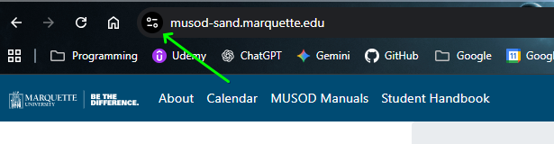

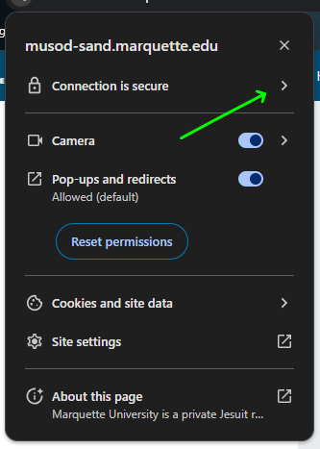
Next click on the connection details. (It should say that the connection is secure.

The next menu should say the certificate is valid. Optionally you can view the details.
